Experiment No. 5
Fourier Series Analysis of Periodic Signals

5.4. To reconstruct periodic signals using Fourier series and verify the reconstructed waveform with the original signal.

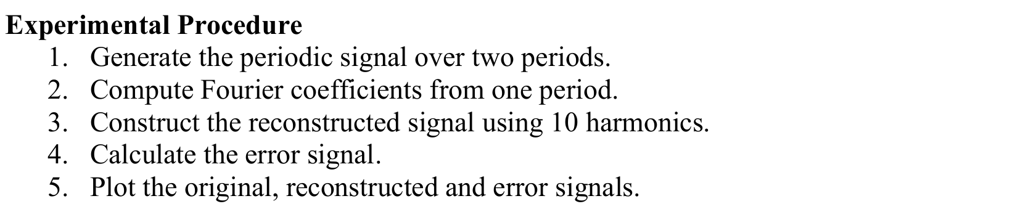
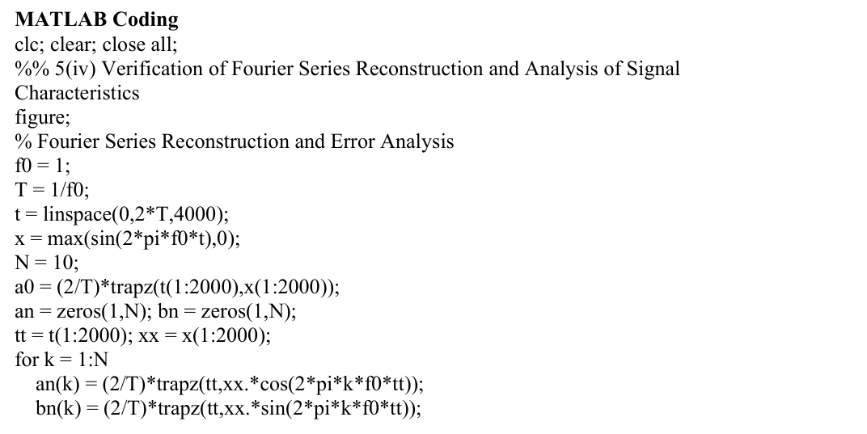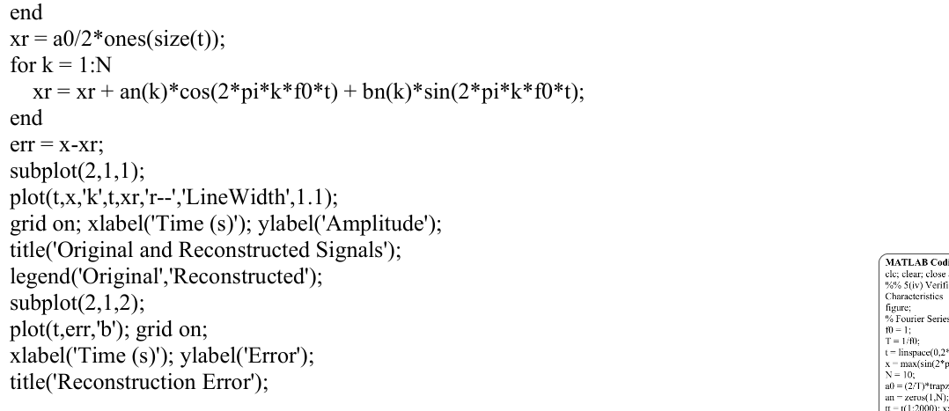
Output:

